Assignment 1

Secure Programming

B00159127 Lan Ngai, B00159763 Kai Guy

Contents

Executive Summary 3

Scope 4

Findings 5

1. Path Traversal & Arbitrary File Read 5

Impact of Path Traversal: 5

Proof of Concept 5

Remediation Steps 6

2. Authentication Bypass 7

3. SQL Injection 9

Remediation Steps: 10

4. IDOR 12

5. Stored XSS 13

6. Credential Leaking 14

7. Shoulder Surfing 15

Remediation 15

8. Resource Exhaustion 17

Conclusion 18

Statement of Contribution 19

Lan Ngai 19

Kai Guy 19

Figures

Figure 1.1 - Source code showcasing path traversal vulnerability 6

Figure 1.2 - URL crafted to download the entire DB through path traversal 6

Figure 1.3 - Successful download of database due to path traversal 6

Figure 1.4 - Visiting the same URL that enabled path traversal after applying the fix 7

Figure 1.5 - The “Unauthorized access attempt” properly displays 7

Figure 3.1 - SQL injection on the login page. 9

Figure 7.1 Before Remediation 15

Figure 7.2 Changes in the source code 15

Figure 7.3 After Remediation 16

# Executive Summary

This report outlines several critical vulnerabilities discovered in the web application provided to the students. Remediation steps are provided for each vulnerability, which currently allow access to sensitive user data and other potentially sensitive and destructive abilities.

# Scope

The scope of this assessment is limited to the running application, and its source code.

# Findings

## Path Traversal & Arbitrary File Read

#### Severity:

Critical

### Impact of Path Traversal:

Path Traversal enables attackers to potentially gain access to information without authentication, this includes the sites source code, database, operating system files, etc.

In some cases, just path traversal can give an attacker enough information about a system to launch further attacks.

This obviously leads to data breaches and breaches the privacy of the users.

### Proof of Concept

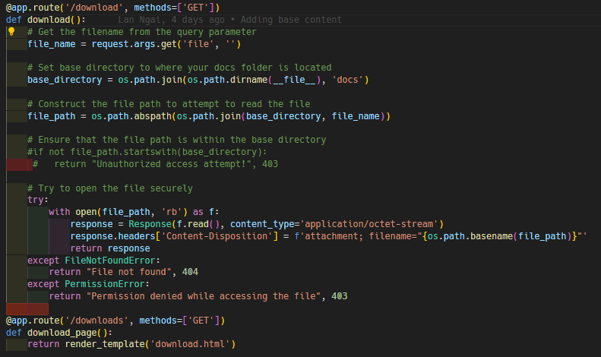

Figure 1.1 - Source code showcasing path traversal vulnerability

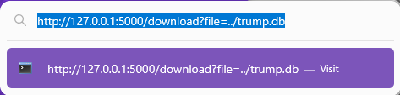

Figure 1.2 - URL crafted to download the entire DB through path traversal



Figure 1.3 - Successful download of database due to path traversal

### Remediation Steps

The simple fix to this **CRITICAL**vulnerability is surprisingly already in the source code, however it is commented out.

To repair the vulnerability, simply uncomment the code and you will no longer be able to traverse the directory structure beyond the “docs” folder.



Figure 1.4 - Visiting the same URL that enabled path traversal after applying the fix

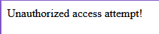

Figure 1.5 - The “Unauthorized access attempt” properly displays

## Authentication Bypass

‘/admin_panel’ shown in requests when clicking on the sitemap option on the website. That’s how that page was made known to us.

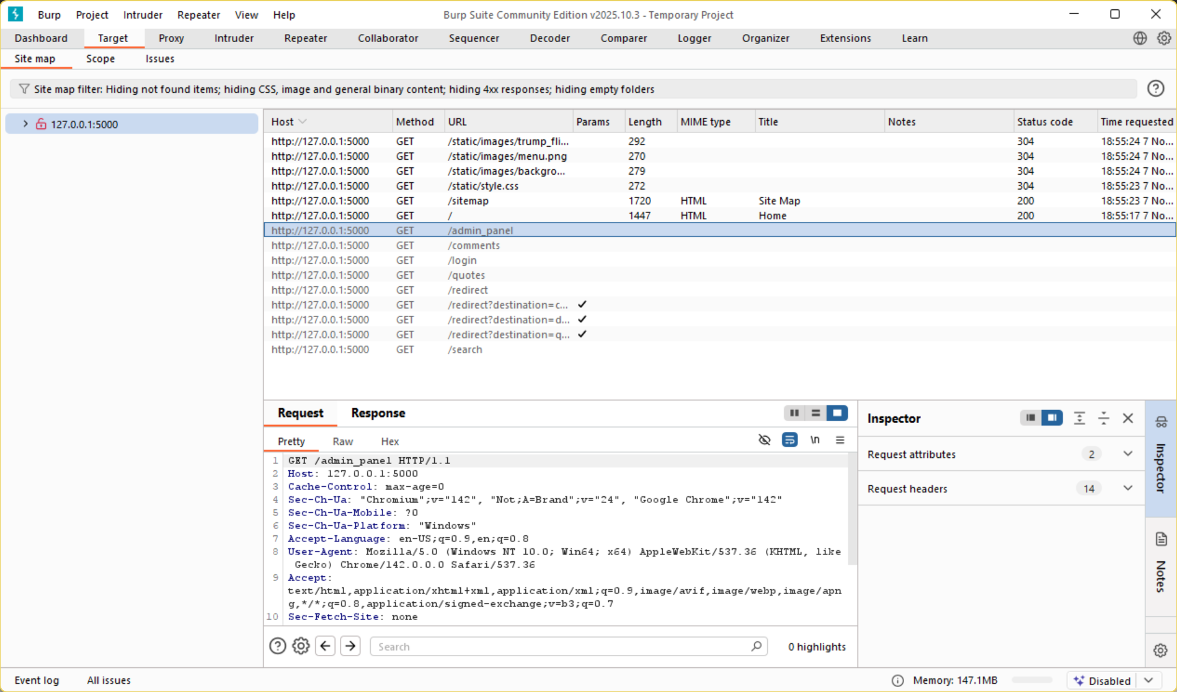

Adding ‘/admin_panel’ we get access to that page which is visible without logging in.

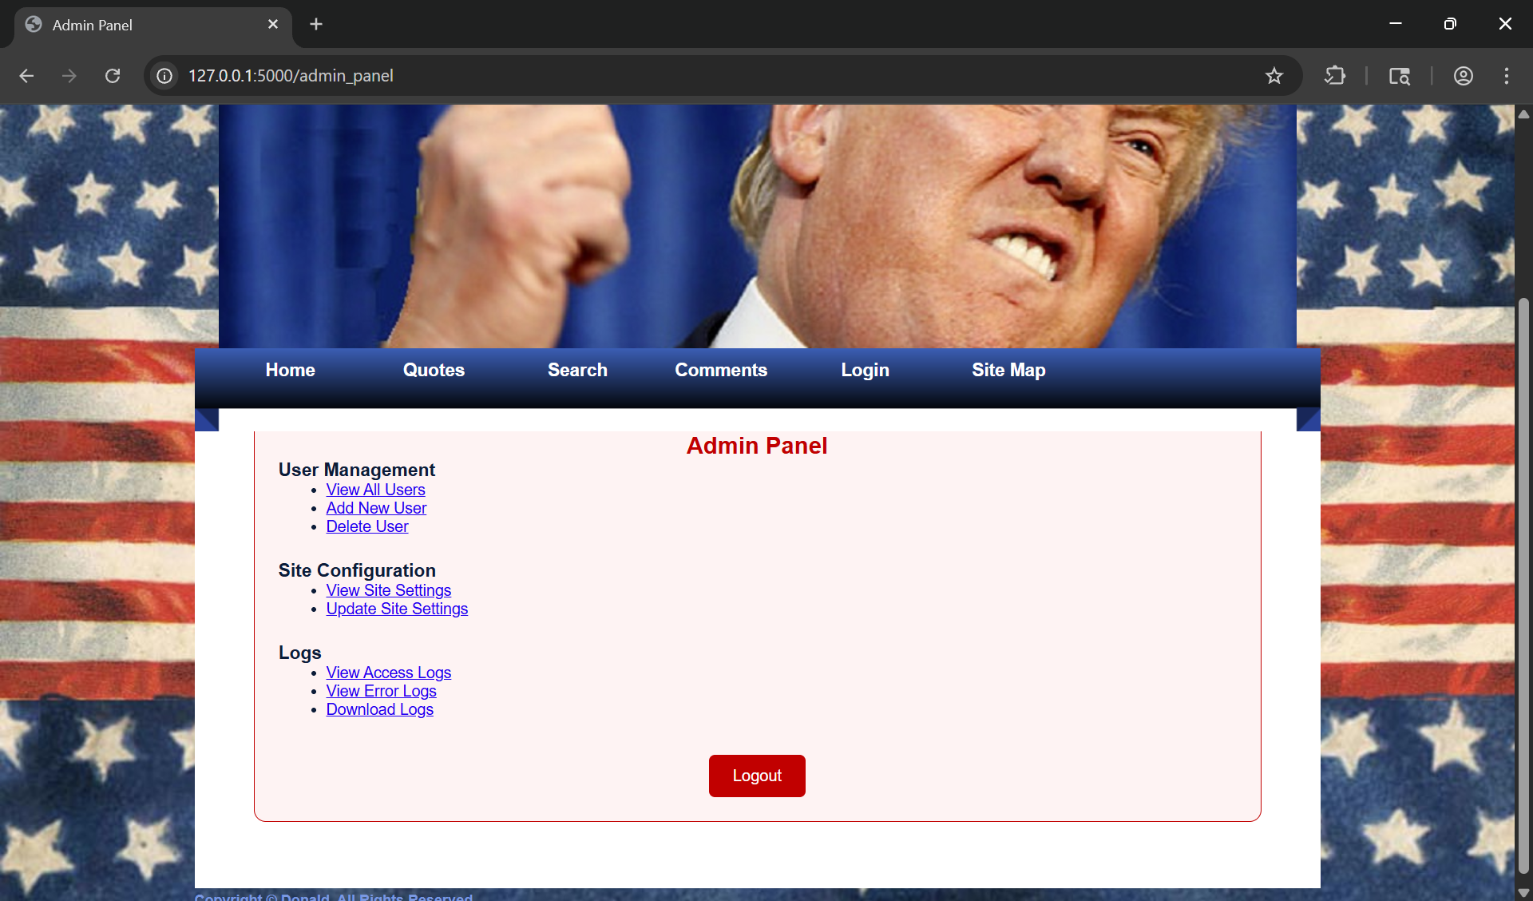

## SQL Injection

#### Severity:

High (NIST:NVD – 8.8) to Critical (CAN: GitHub, inc. – 10.0)

### Impact:

The impact would include allowing an attacker to access sensitive information stored in the database as well as modifying that information.

### Proof of Concept:

In the login page by putting the following (‘OR 1=1 --) in both the username and password fields logs you in due to that being a statement which is always true. The original code allows for this exploit because it uses formatting to directly concatenate user input.

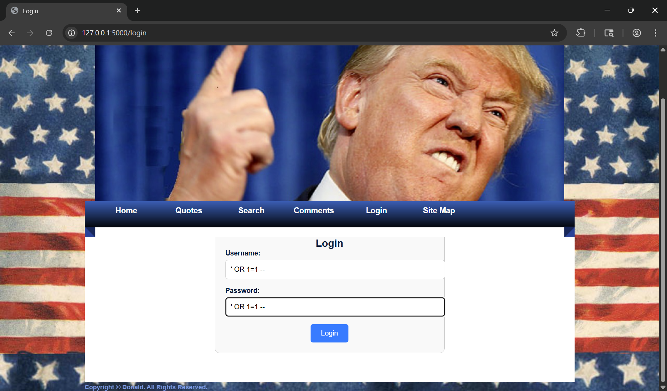

Figure 3.1 - SQL injection on the login page.

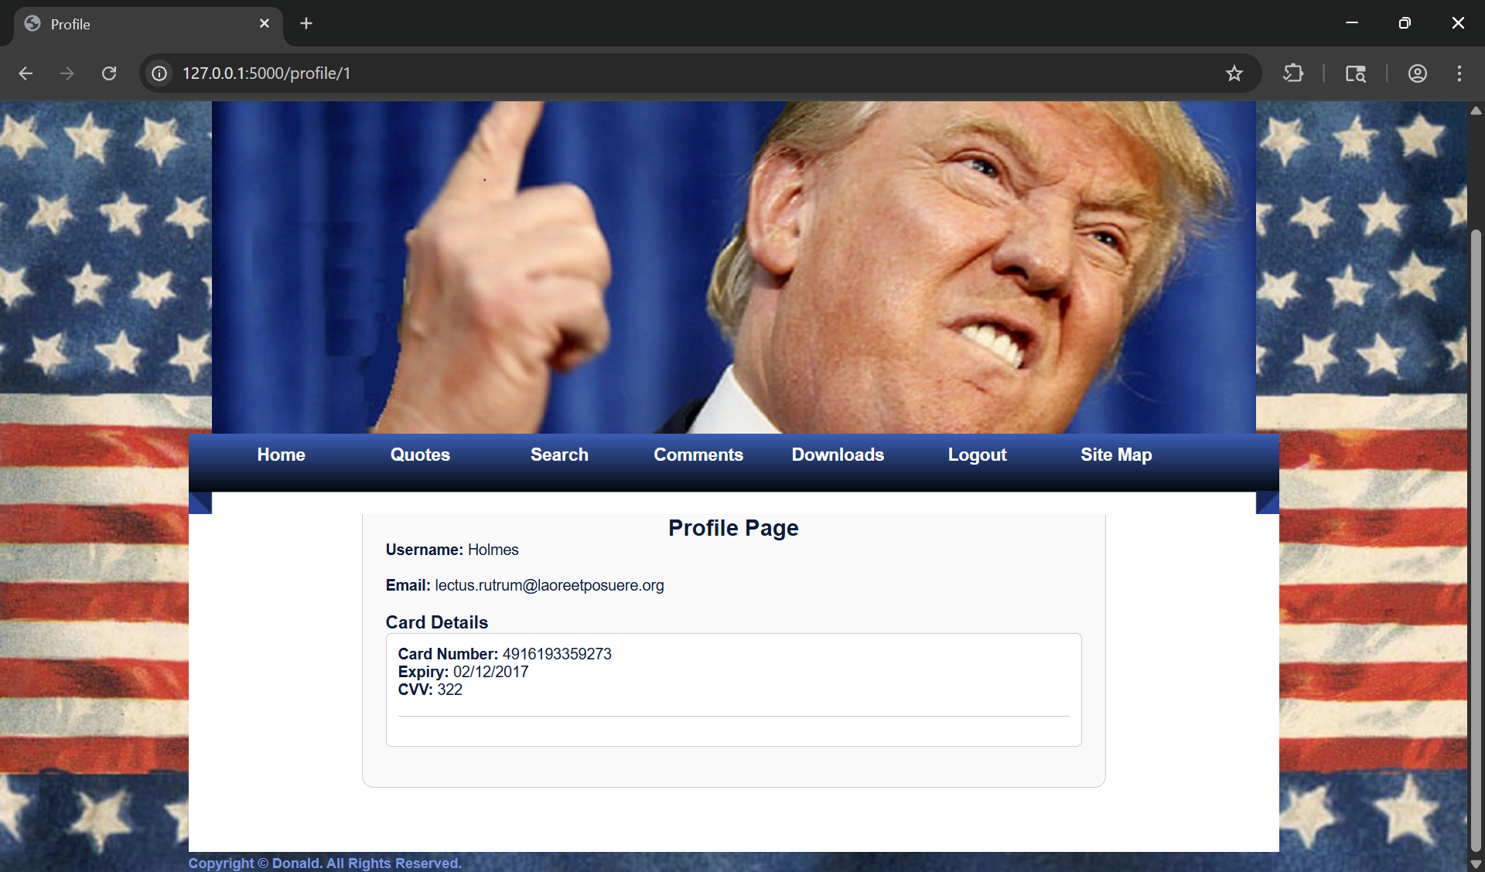

Figure 3.2 – Profile accessed through the SQL injection

### Remediation Steps

Before:



Figure 3.3 - Code vulnerable to SQL injections in app.py

After:

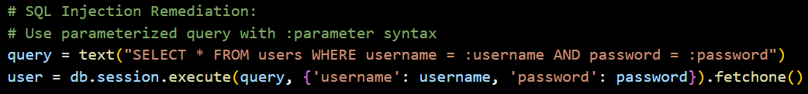

Figure 3.4 - Remediation attempt made in app.py

The fixed version uses a parameterized query with placeholders, ‘:username’ and ‘:password’. This separates the data to be inserted and the query itself. This means that the user data entered will be treated as data and not a SQL query.

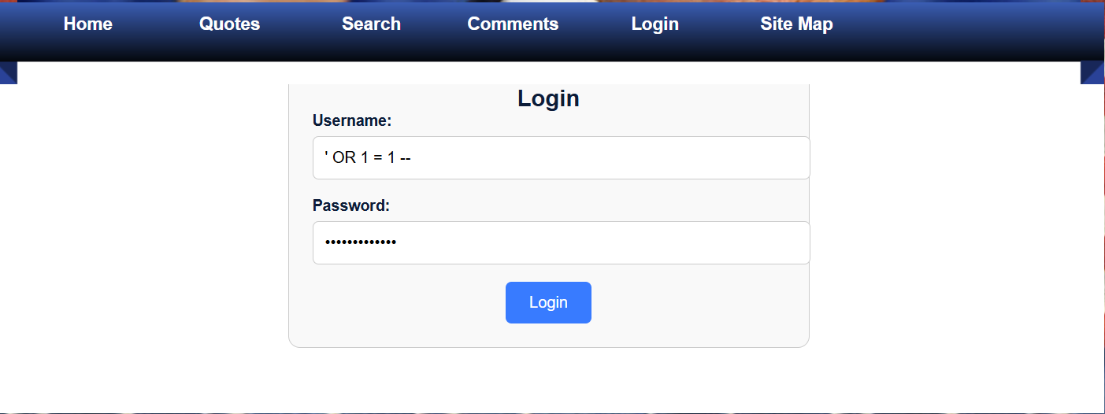

Figure 3.5 - SQL injection attempt after remediation

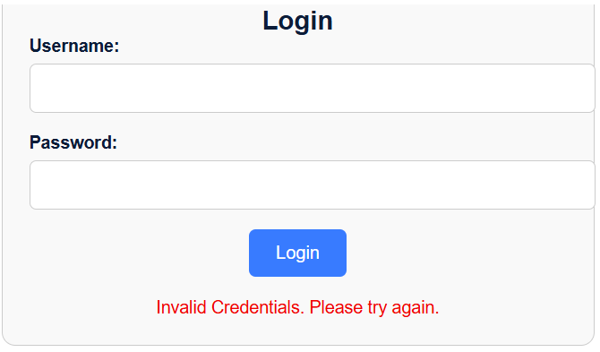

Figure 3.6 - Successful remediation attempt

## IDOR

After that I noticed that the Url changed to <http://127.0.0.1:5000/profile/1> so I changed the number and the profile changed to that of another user.

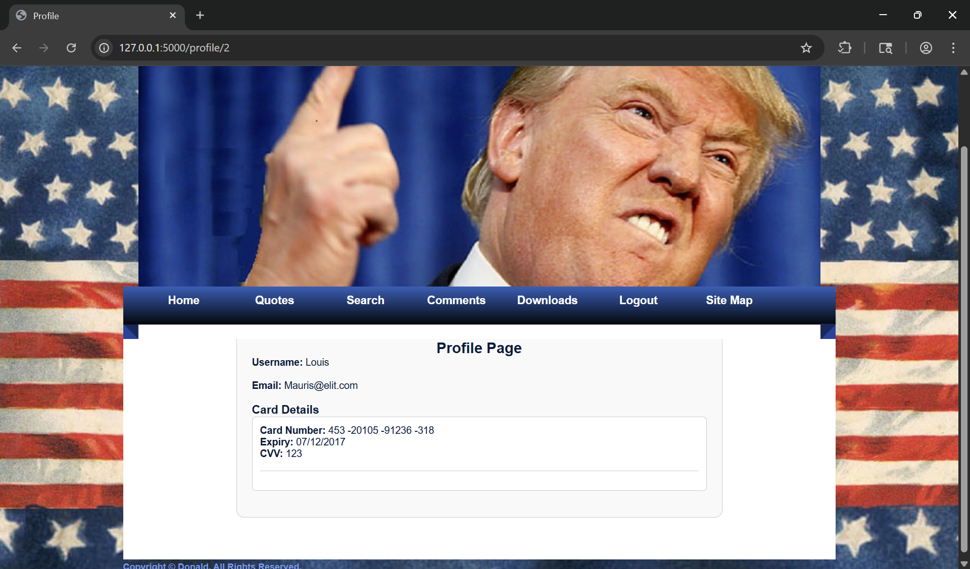

## Stored XSS

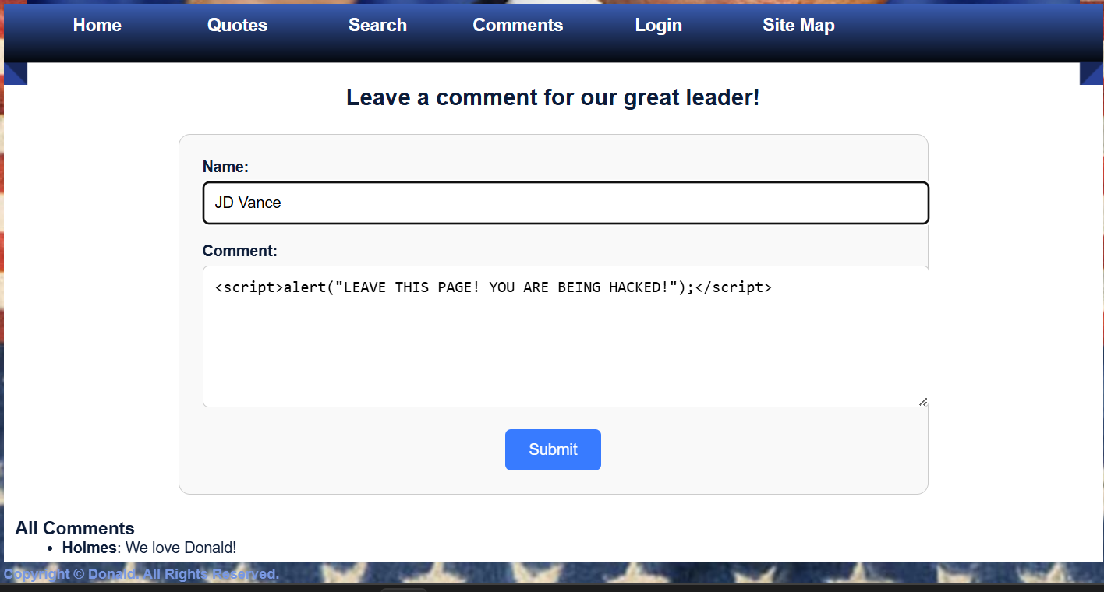

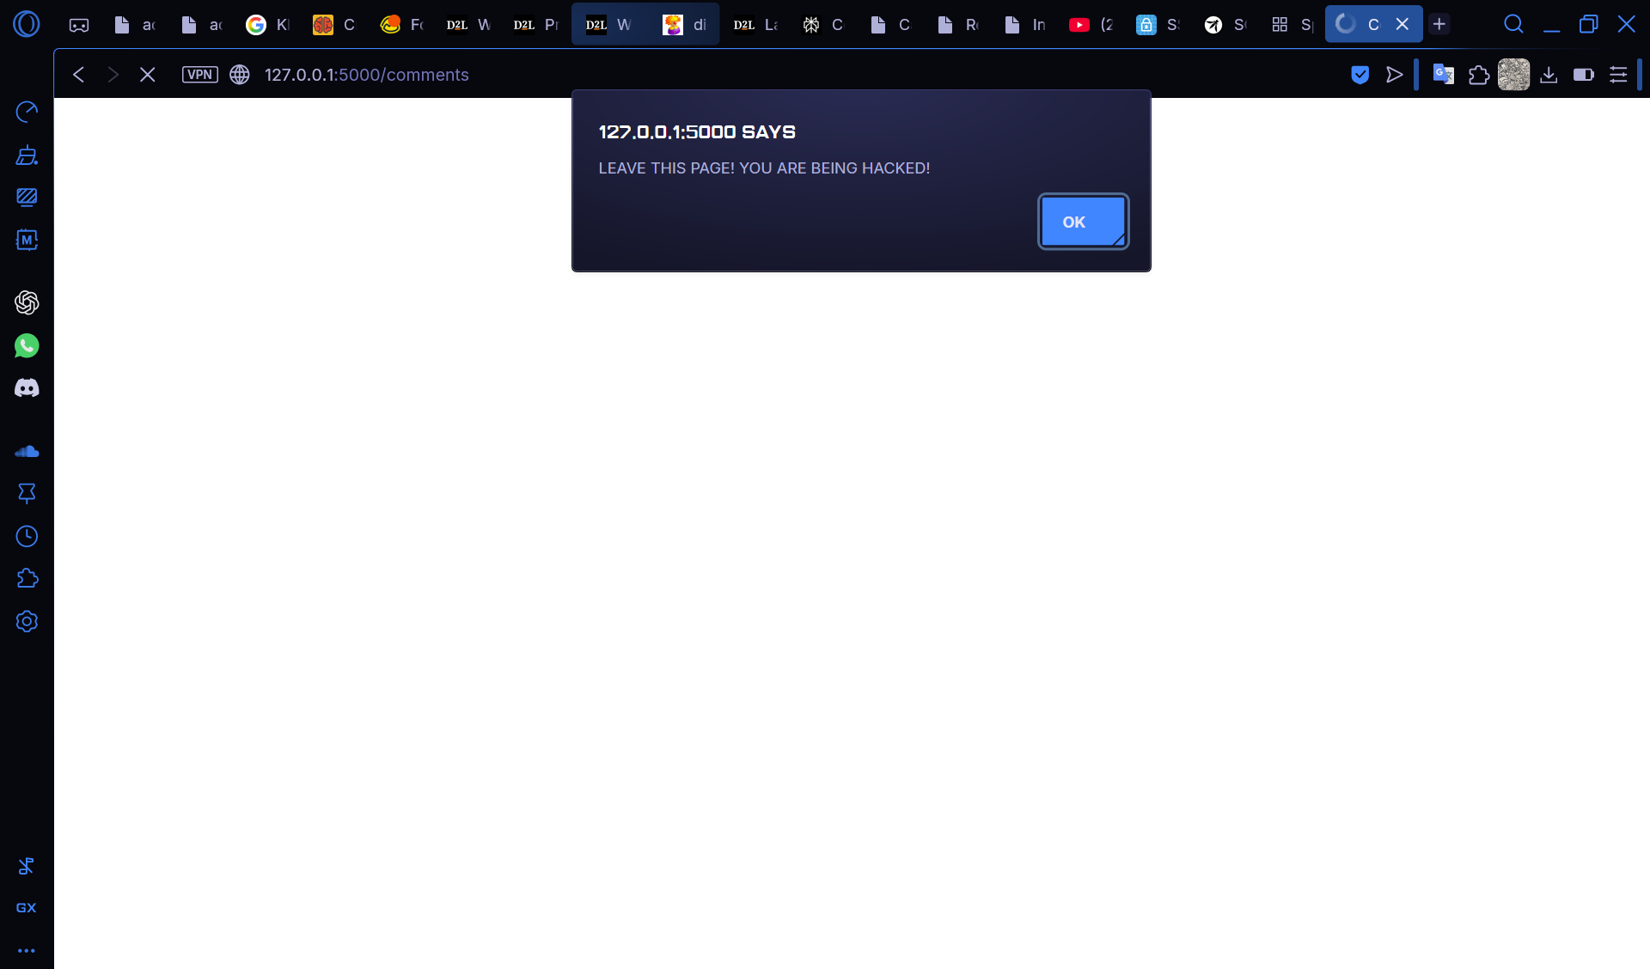

## Credential Leaking

After gaining access to any profile the credit card information of the individual is visible with no hashing or censoring of the sensitive information.



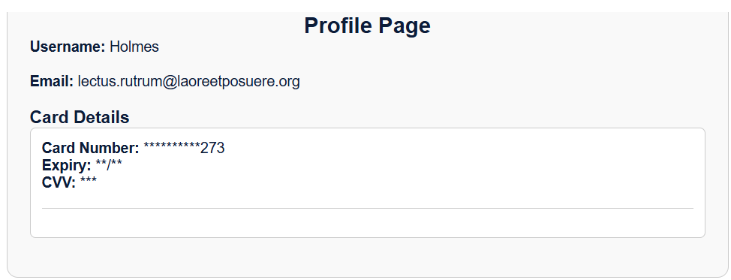

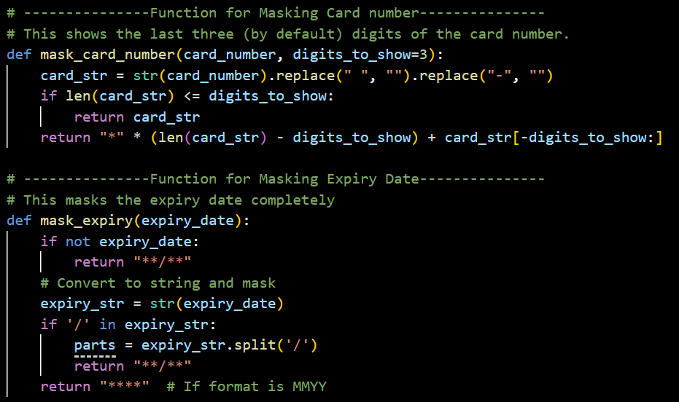

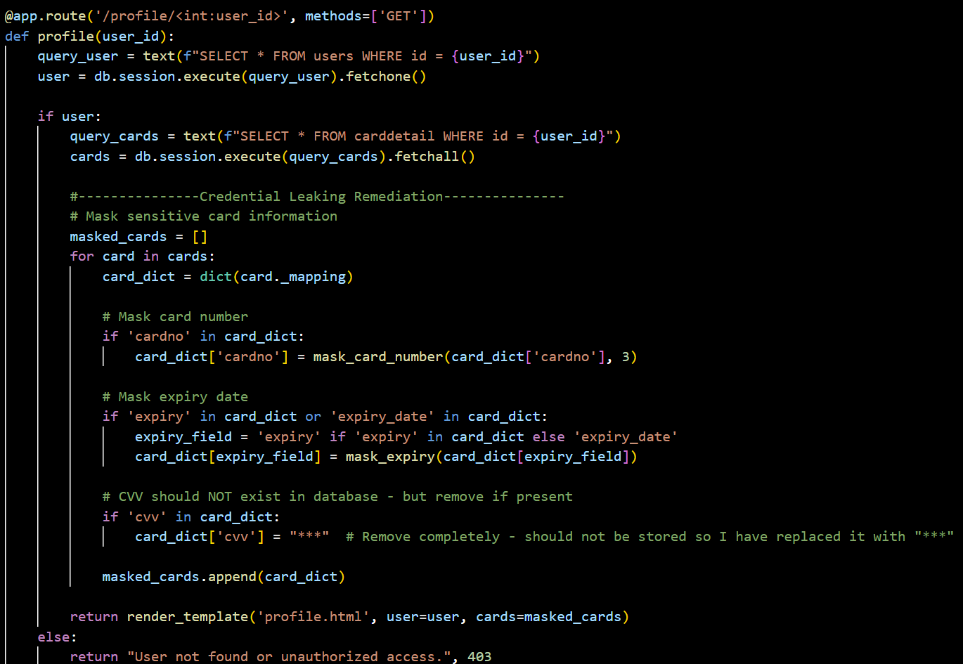

## Shoulder Surfing

The password field in the login page remains so that it’s not hidden. This can allow the user to be prone to shoulder surfing as the password entered is clearly visible.

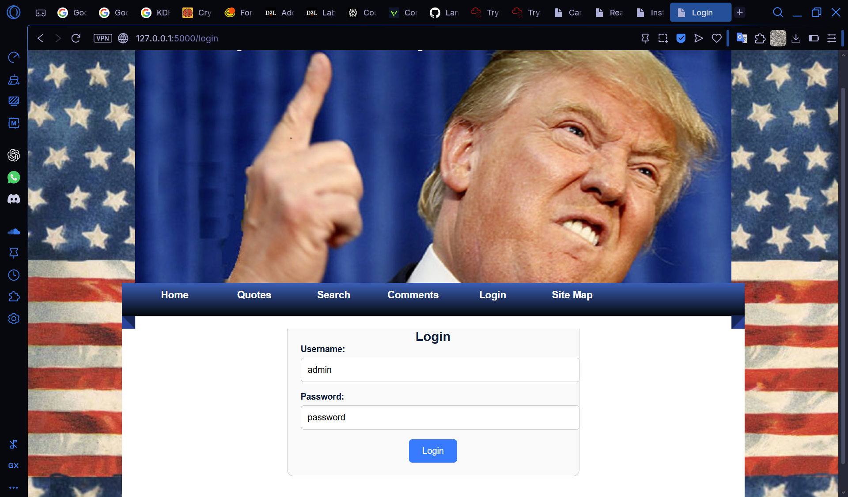

Figure 7.1 Before Remediation

### Remediation

This is a simple fix in the HTML template used. The original had the password field set to a ‘type’ attribute of ‘text’. When the ‘type’ attribute is changed to ‘password’ the entered text is automatically hidden aiding in shoulder surfing prevention. This was introduced since HTML 2.0.

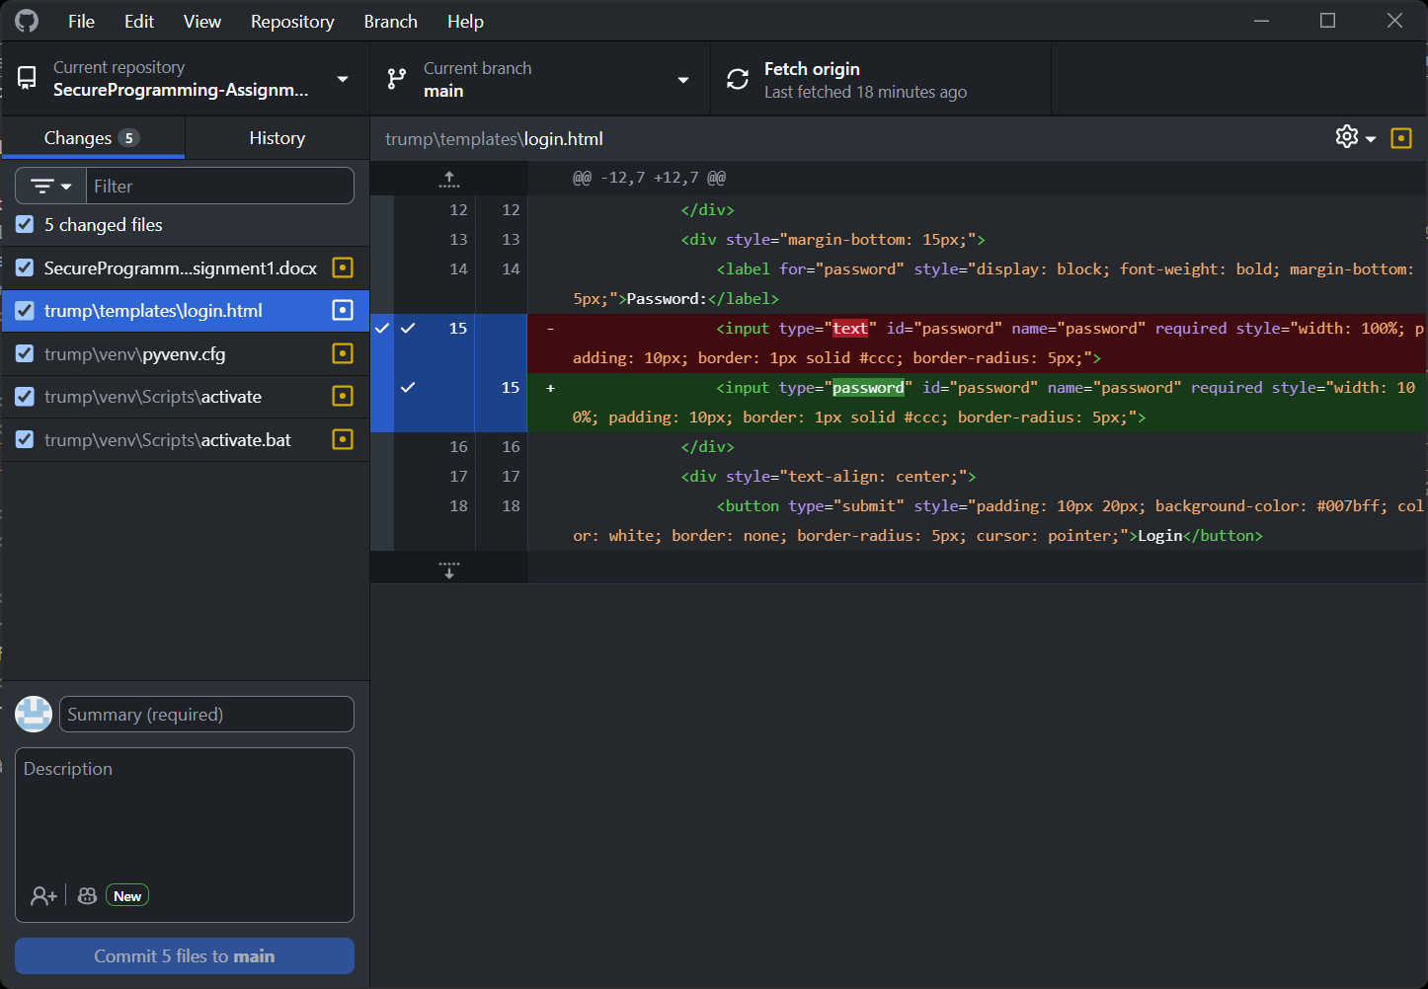

Figure 7.2 Changes in the source code

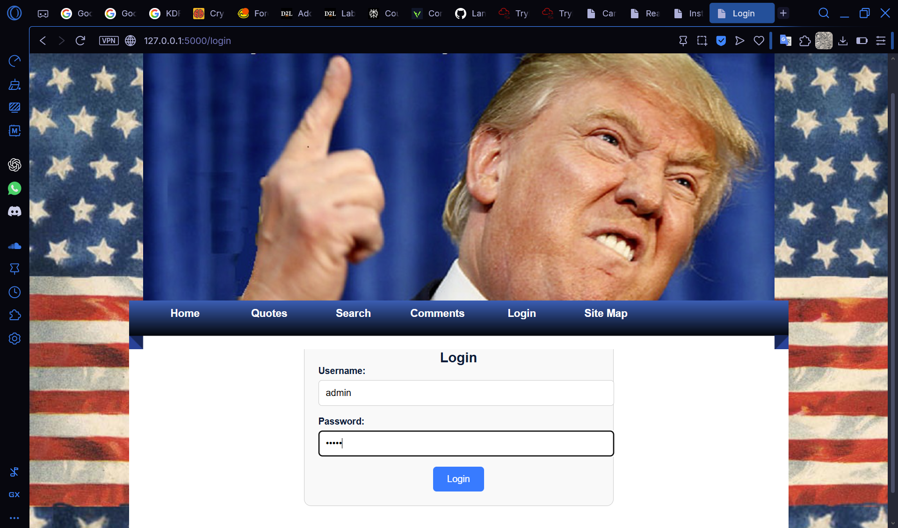

Figure 7.3 After Remediation

## Resource Exhaustion

The comment section of the website does not have a limiter of any sort. This leaves room for malicious individuals to flood the service potentially leading to a denial of service or rapid performance downgrade. This could be taken advantage of through the use of bots or automated tools.

# Conclusion

# Statement of Contribution

## Lan Ngai

## Kai Guy